JAMHUURIYA UNIVERSITY AND TECHNOLOGY

NAME: Sihaam Abdullahi Mohamed
ID: C6240157
CLASS: CNS242
SUBJECT: LINUX
ASSIGNMENT: CHAPTER 1,2,3,4

INTRODUCTION TO LINUX AND UBUNTU
LINUX COMMENDS AND OPTIONS CHAPTER1

1=WHOAMI
displays the username of the currently logged-in user.
Commend options
--help : displays help information about the commend
--version : displays the commend version
Practice screenshot
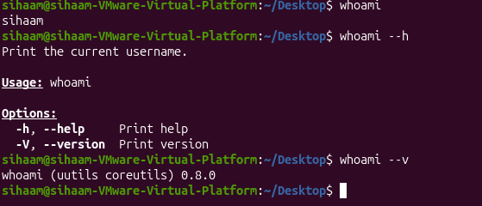

2=pwd
pwd commend displays the path of the current working directory
Commend options
-l displays logical current directory uses path with sympolic links
-p displays the physical directory path (resolves symbolic links)
Practice screenshot
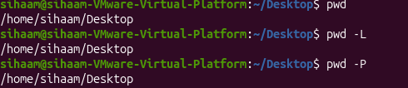
3=uname
The uname commend displays information about the operating system and the running karnel
Commend options
-s displays the operating system name
-r displays the kernel release
Practice screenshot
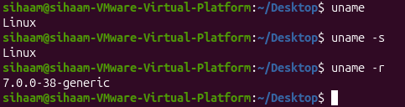
4=cat
The cat commend displays the contents of file

The commend shown this chapter
Cat/etc/os-release this commend displays information about linux distribution , including its name and version
Practice screenshot
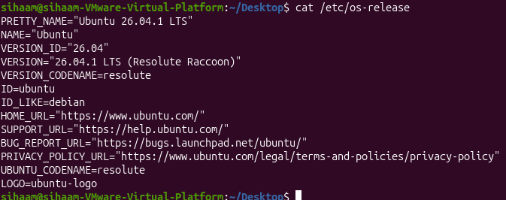
5=ls
The ls commend lists files and directories in the current directory
The commend options
-l displays files in long format with permissions owner,size and data
-a displays all files including hidden files
-h displays file sizes in human-redeable format when used with -l
-r lists files and directories recursively including subdirectories
Practice screenshot
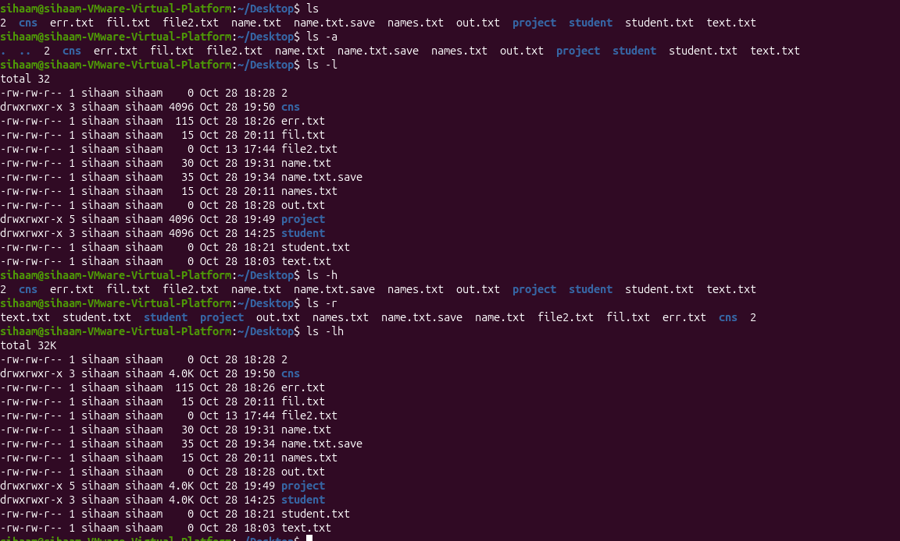

LINUX SYSTEM ARCHITECTURE,
COMMEND LINE,AND FILE MANAGEMENT
COMMEND AND OPTIONS CHAPTER2

1:CD(change directory)
CD moves from one directory to another
Commend options
Cd = moves to the home directory
Cd ~= moves the home directory
Cd /etc = moves to the /etc directory
Cd .. = moves one level up to the parent directory
Cd . = stays in the current directory
Cd - = returns to the previous directory
Cd documents = enters the documents directory
Practice screenshot
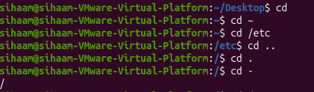

2 = ls (list directory contents)
Ls displays files and directories
Commend options
-a =displays all files including hidden files
-l =displays detailed information in a long listing
-h =dispalys file sizes in readeble units(K,M,G)
Practice screenshot
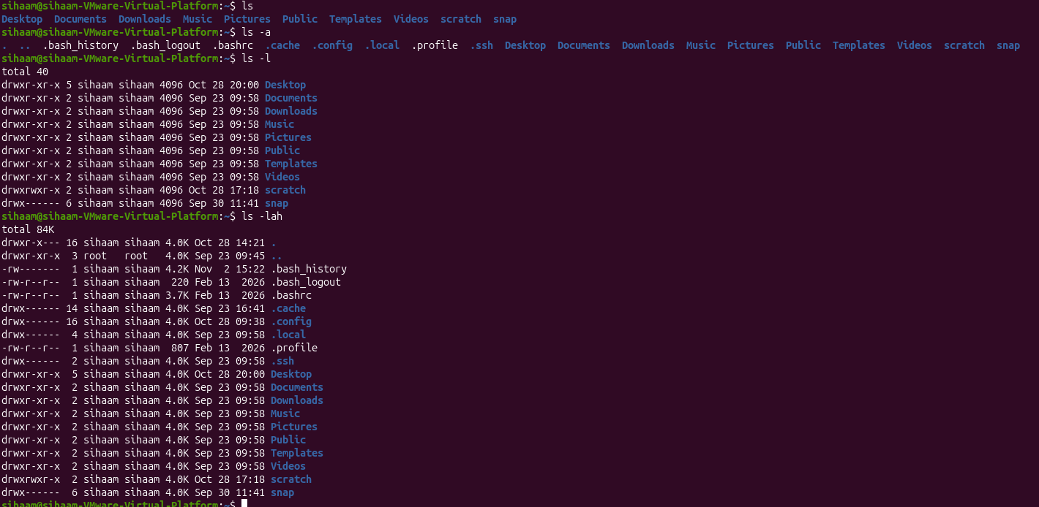

3=touch
Touch Creates empty files or updates the modification time of existing files

Practice screenshot
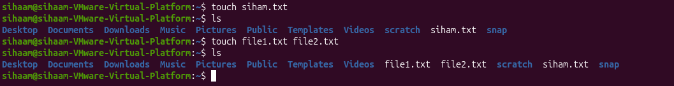

4=mkdir(make directory)
Mkdir Create new directories
Commend options
-p /--parents creates missing parent directories
Practice screenshot
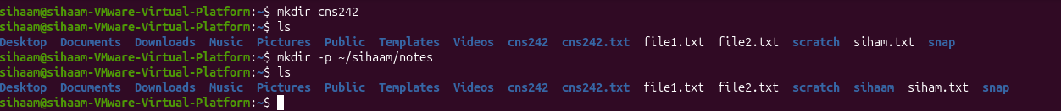

5=rmdir(remove directory)
Removes empty directories
Commend options
-p= removes empty parent directories as well

Practice screenshot

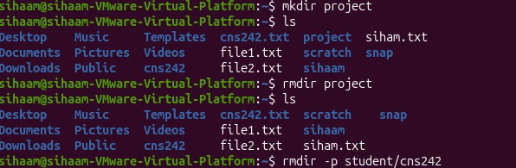

6=cp(copy files and directories)
Cp copies files and directories from one location to another
Commend options
-r copies directories and their contents
-i ask before overwriting an existing file

Practice screenshot
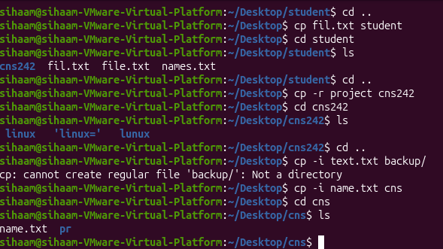

6=mv (move or rename files)
Moves files or directories and rename them
Commend options
-i ask before overwriting an existing file

Practice screenshot
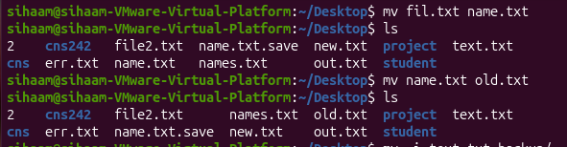
7=rm(remove files and directories)
Delete files and directories
Commend options
-i=ask confirmation before removing each file
-r= removes directories and their contents
-f= forces removal without prompting and ignores nonexistent files

Practice screenshot

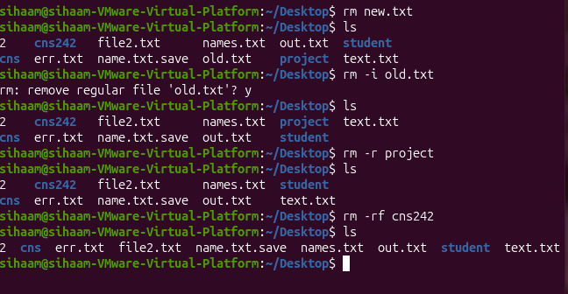

8= echo
Prints text or variables values on the terminal
Practice screenshot
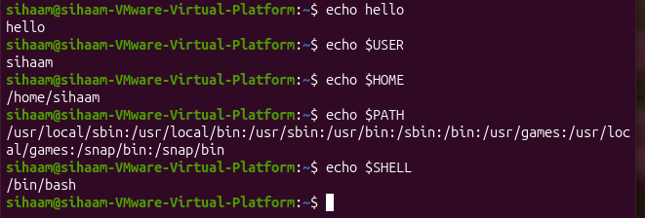

9= export
Makes a shell variable available to programs started from the current shell
Practice screenshot
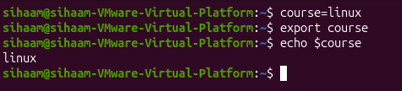
10= source
Reads and applies commends from a shell configuration file in the current shell
Practice screenshot
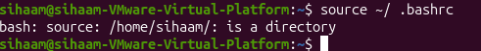

11=history
Displays previously excuted commends
Practice screenshot
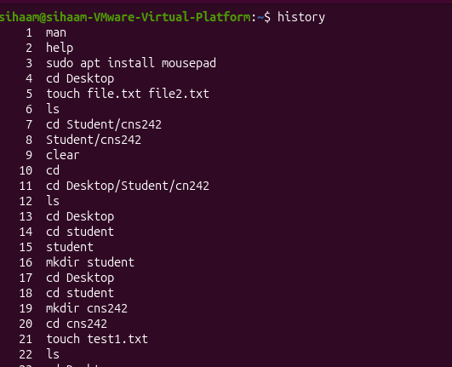

12= help
Displays help information about bash built-in commends
Practice screenshot
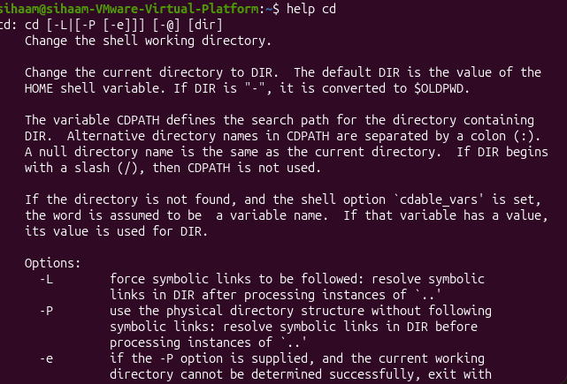

TEXT,PROCESSING,SEARCHING,ARCHIVING,
AND EDITORS
COMMEND AND OPTIONS CHAPTER3
1=CAT
Displays the contents of text files and combines multiple files
Commend options
-n number all output lines
Practice screenshot
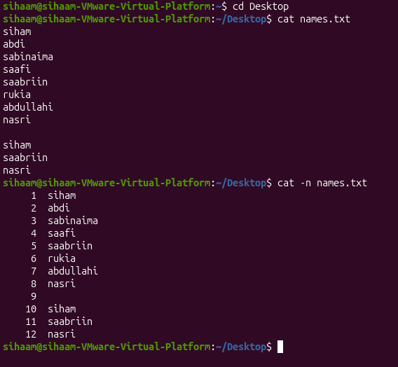
2=less
Displays long files one screen at a time and allows forward and backward navigation
Commend options
Space = move forward one screen
b= move backward one screen
/word= search for a word
n= find the next match
q= quit the viewer
3=more =displays a text file one screen at a time
Commend options
Space=move to the next screen
q=quit the viewer
Practice screenshot
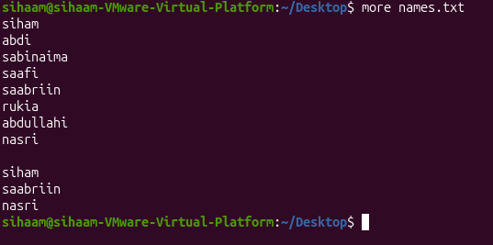
4=head
Displays the beginning of a file by default it shows first 10 lines
Commend options
-n specify the number of lines to display
Practice screenshot
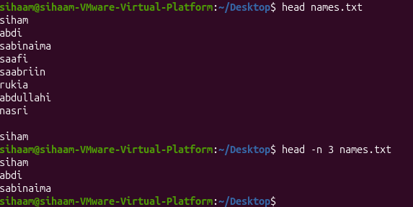

5=tail
Displays the end of a file
Commend options
-n specify the number of lines to display
-f continuously monitor new lines added to a file

Practice screenshot
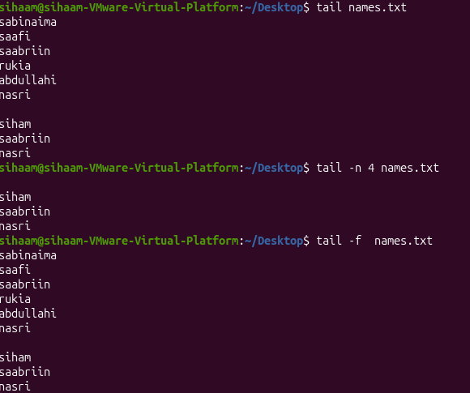
6=file = identifies the actual type of a file
Practice screenshot
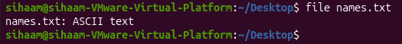
7=stat = displays detailed information about a file,including its size ,permissions,owner,and time stamps
Practice screenshot
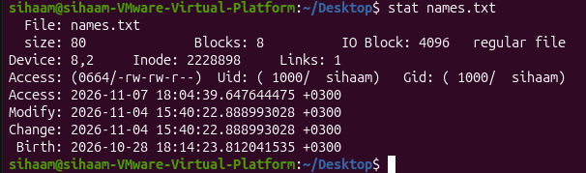

8=which locates the executable file of a commend by searching directories in the path environment variable
practice screenshot
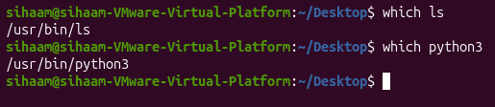
9= type identifies whether a commend is a shell built-in,executable, alias, or function
Practice screenshot
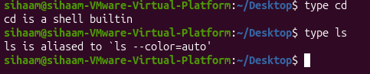
10= command -v finds how a commend is resolved by the shell
Practice screenshot
11= where is locates the executable binary ,source code , and manual pages associated with a commend
Practice screenshot
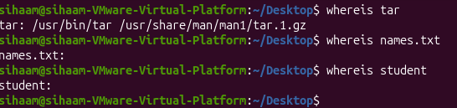
12=find searches for files and directories based on names, types,sizes, permissions,and modification times
Commend options
-name search by file name
-iname search by file name
-type f search for regular files
-type d search for directories
-size search by file size
-m min search by modification time in minutes
Practicescreenshot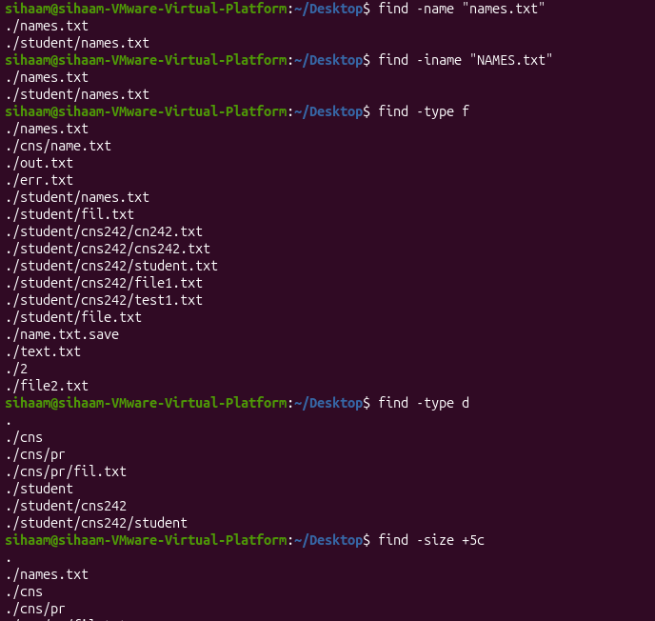
14=locate quickly searches for files and directories using a pre built database of file paths
Practice screenshot
15=grep searches for specific text or patterns inside files and displays matching lines
Commend options
-n display line numbers
-i ignore latter case
-v display lines that do not match the pattern
-r search recursively inside directories
-R search recursively and follow symbolic links
Practice screenshot
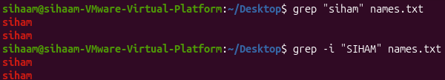

18=>>(append redirection) adds output to the end of a file without deleting existing content
Practice screenshot
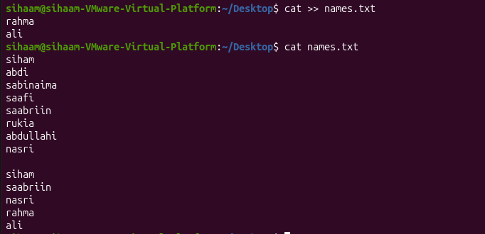

19=2>(error redirection)
Redirects standard error messages to a file
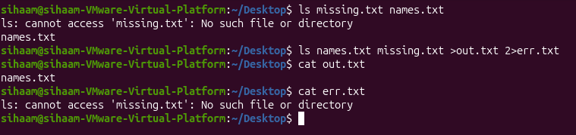

20= <(input direction)
Takes input from a file instead of the keyboard
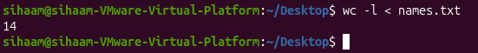
21=| (pipe)
Sends the standard output of one commend as the standard input of another command
22=;(commend separator) executes multiple commends regardless of whether the previous command succeeds or fails
Practice screenshot
23=&& (and operator)
Executes the second command only if the first command succeeds
Practice screenshot
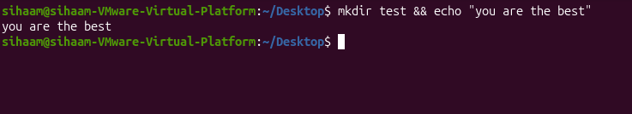
24=||(or operator)
Executes the second commend only if the first command fails
25=sort arranges lines of text alphabetically or numerically
Commend options
-n sort numerically
-r reverse sorting order
Practice screenshot
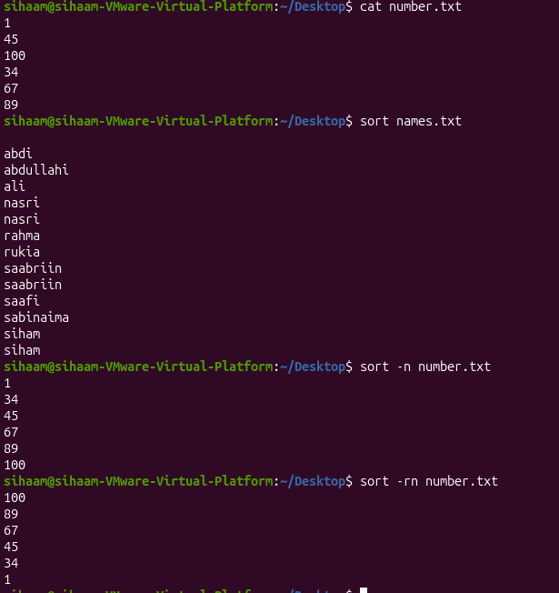
26=uniq removes adjacent duplicate lines from input
Commend options
-c count repeated lines
-d display only duplicate lines
Practice screenshot
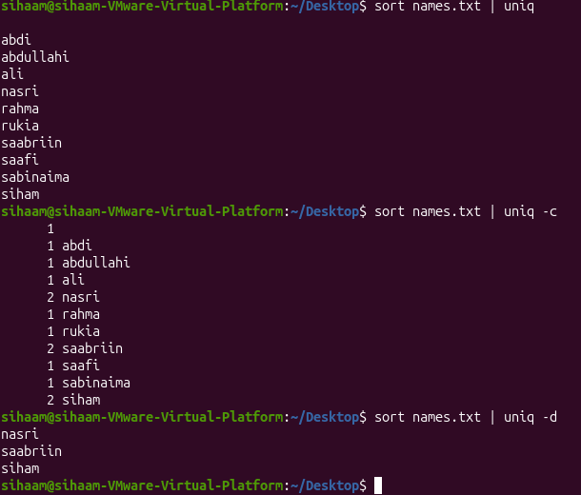
27= cut extracts specific character ,bytes,or fields from each line of text
Commend options
-d specify the delimiter
-f select specific fields
-c select specific characters
Practice screenshot
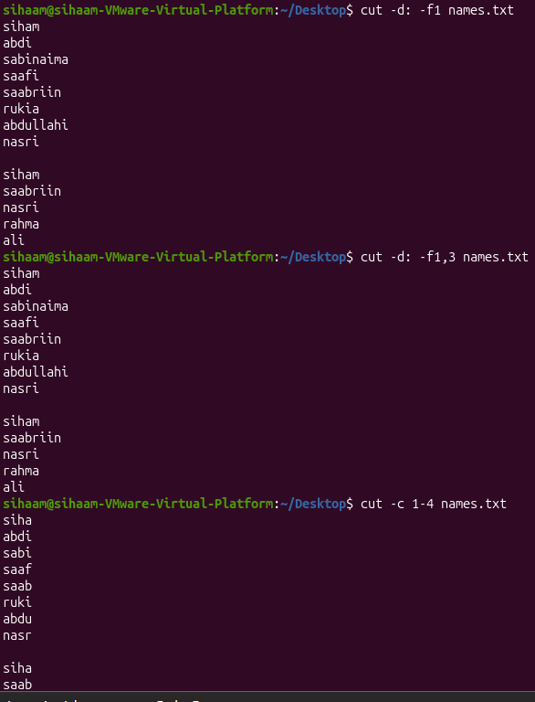
28=paste combines corresponding lines from two or more files into one line
Commend options
-d specify the delimiter
-s merge lines serially from each line
Practice screenshot,
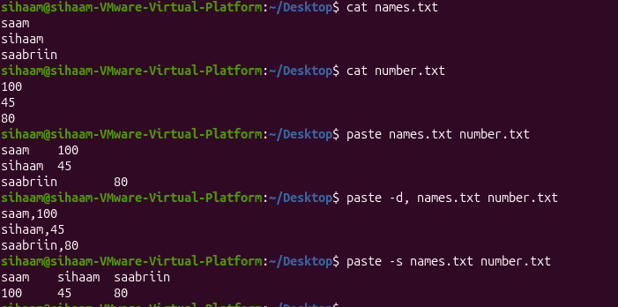
29=WC (word count) counts lines, words, characters,and bytes in a file or input
Commend options
-l count lines
-w count words
-c count bytes
-m count characters
Practice screenshot
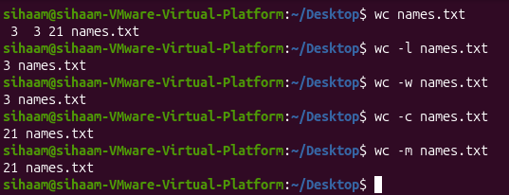
30=tr translates, deletes, or squeezes repeated characters
Commend options
-d delete specified characters
-s squeeze repeated characters into one
-c complement the specified character set

Practice screenshot
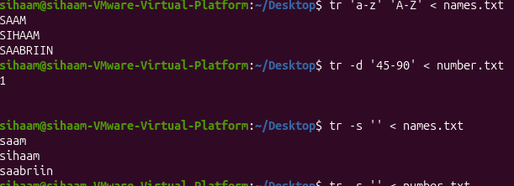
31= tar combines multiple files and directories into a single archive and extracts archive files
Commend options
-c create new archive
-x extract files from an archive
-v display processes file names
-f specify the archive file name
Practice screenshot
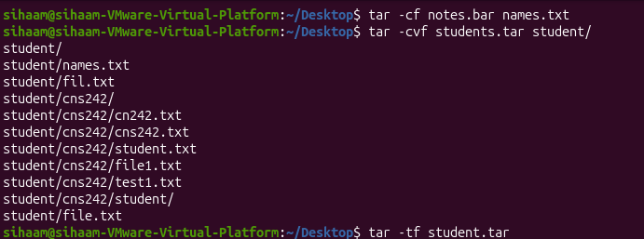
32=nano opens and edits text files directly in the Linux terminal
Practice screenshot
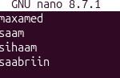
33=vim opens and edits text files using a model text editor
Practice screenshot
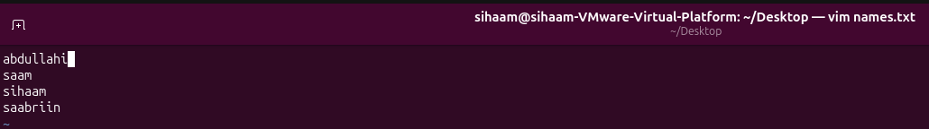
34=Ln creates a hard link, which provides another filename for the same inode and file data
Practice screenshot
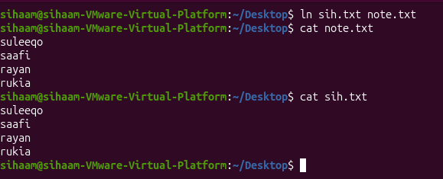

PROCESS, SERVICE, AND
SYSTEM MANAGEMENT
COMMEND AND OPTIONS CHAPTER4

1=PS(process status) displays information about running processes
Commend options
-p PID displays information about a specific process
-o selects the columns to display
Aux displays process from all users with detailed information
Practice screenshot
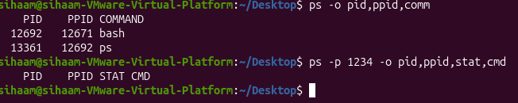
2= top displays running processes and system resource usage in real time
Commend options
-u USER display processes belonging to a specific user
P sorts processes by CPU usage
M sorts process by memory usage
K sends a signal to a process
R changes the priority of a process
Q quits the program
Practice screenshot
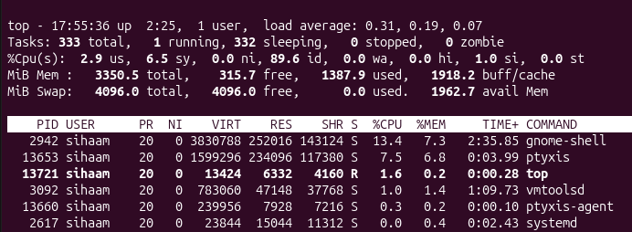
3=HTOP displays processes interactively using a user-friendly interface
Commend options
-u USER displays processes belonging to a specific user
-t displays processes in a tree view
F6 selects the sorting column
F9 sends signal to the selected process
F10 exits the program
Q quit the program
4=jobs lists jobs running or stopped in the current terminal
Commend options
-l displays job numbers and process IDs
5=bg background resumes a stopped job in the background
Commend options
%N specifies the job number to resume
No argument resumes the current job
Practice screenshot
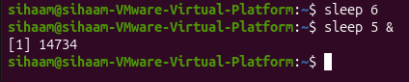
6=fg foreground brings a background or stopped job to the foreground
Commend options
%N specifies the job number to resume
No argument resumes the current job
Practice screenshot

7= kill(terminate a process) sends a signal to a process using its PID
Commend options
-term requestsa process to terminate normally
-kill forces a process to terminate immediately
-9 sends the SIGKILL signal
-l lists available signal names
8=PGREP process search searches for running process by name
Commend options
-a displays the PID and full commend line
9=PKILL sends a signal to processes by matching their names
Commend options
-u USER targets processes belonging to a specific user
10= KILLALL terminates processes using their exact process names
11= nice starts a process with a specified niceness value
Commend options
-n N sets the niceness value of a new process
No option displays the current niceness value

Practice screenshot
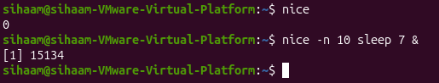
12= RENICE changes the niceness value of an already running process
Commend options
-n N specifies the new niceness value
-p PID specifies the process id to modify
13 hostnamectl displays the hostname and operating system information
Commend options
Hostname displays the hostname
14= uptime displays how long the system has been running and its load average
Commend options
-p displays uptime in a human-readable format
-s displays the data and time when the system booted

Practice screenshot
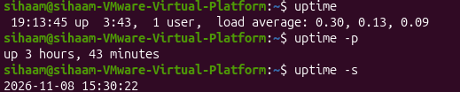
15= free displays the amount of free and used memory
Commend options
-h displays memory sizes in human-readable format
-m displays memory sizes in megabytes
-s N repeats the memory report every N seconds
Practice screenshot
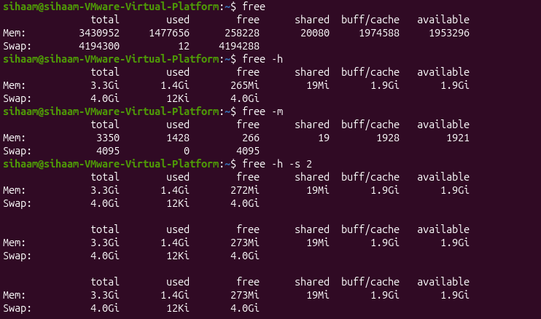

16= lscpu displays detailed information about the CPU architecture
Practice screenshot
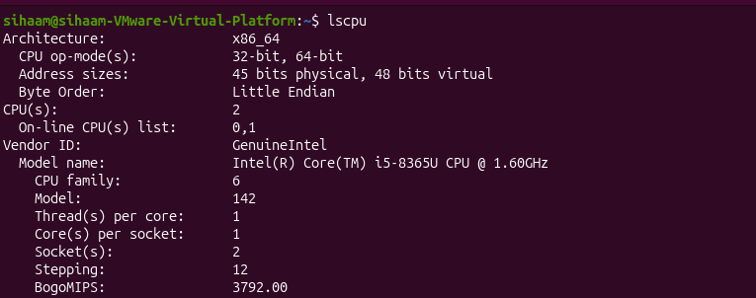
17=NPROC(number of process) displays the number of processing units available
Practice screenshot
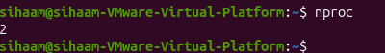
18= LSBLK(list block devices) displays information about disks, partitions, and block devices
Commend options
-e 7 hides devices with major device number 7
-d displays whole disks only
-0 COLS selects the columns to display
Practice screenshot
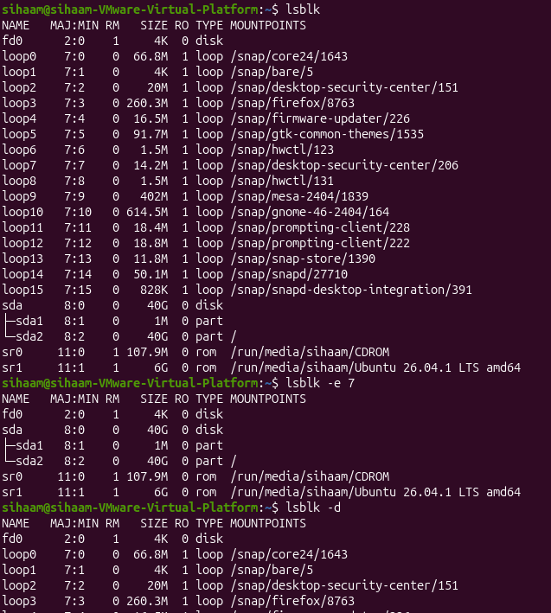
19=/PROC provides virtual files containing live information about processes and the system
Practice screenshot
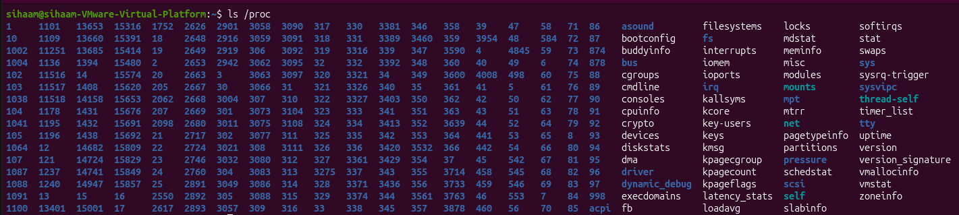

20=/SYS provide information about devices, drivers, and kernel objects

Practice screenshot
21=/var/log stores system and application log files
Practice screenshot
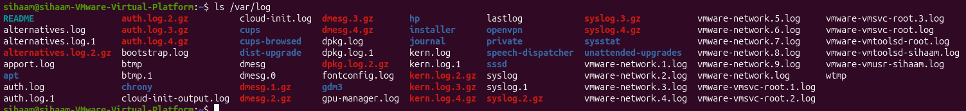
22=shutdown shuts down or restarts the system safely
Commend options
Now shuts down immediately
+N schedules shutdown after N minutes
-r restarts the system instead of shutting it down
-c cancels a scheduled shutdown
23=repoot restarts the linux system
24=poweroff shuts down and switches off the computer
25=last (login history) displays previous user login and system reboot records
Commend options
-n N displays the last N records

